1. Sign up for a free Microsoft Azure for Education account here (be sure to claim your free $100 student credit):

<https://azure.microsoft.com/en-us/education/>

1. Do a screen print showing your Azure account is created.

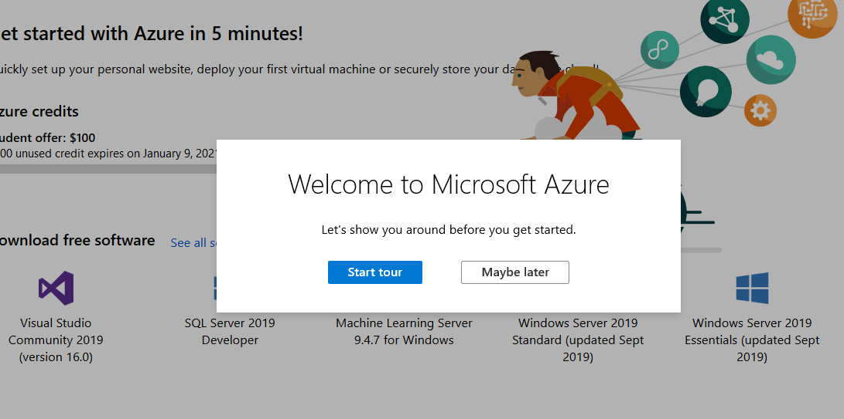

1. Do a screen print of the initial project running in the browser.

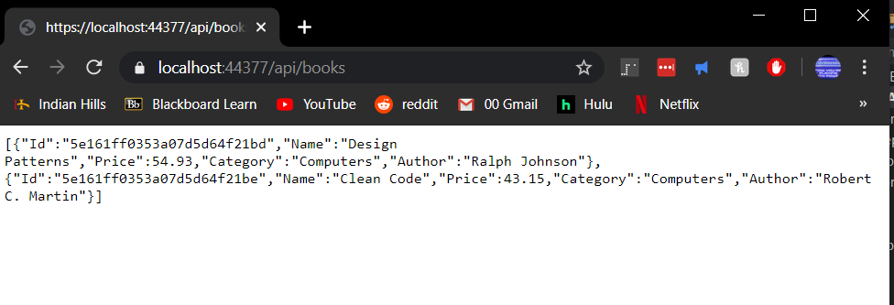

1. After publishing your web app to Azure, do a screen print of it running in your browser.

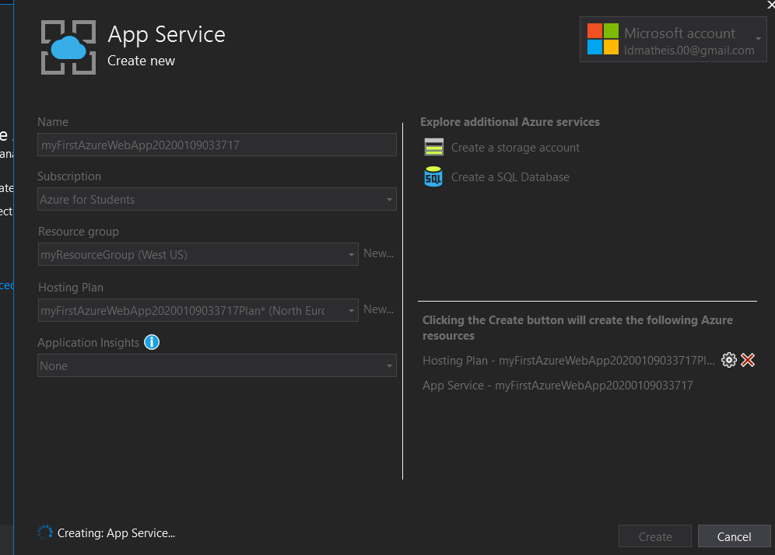

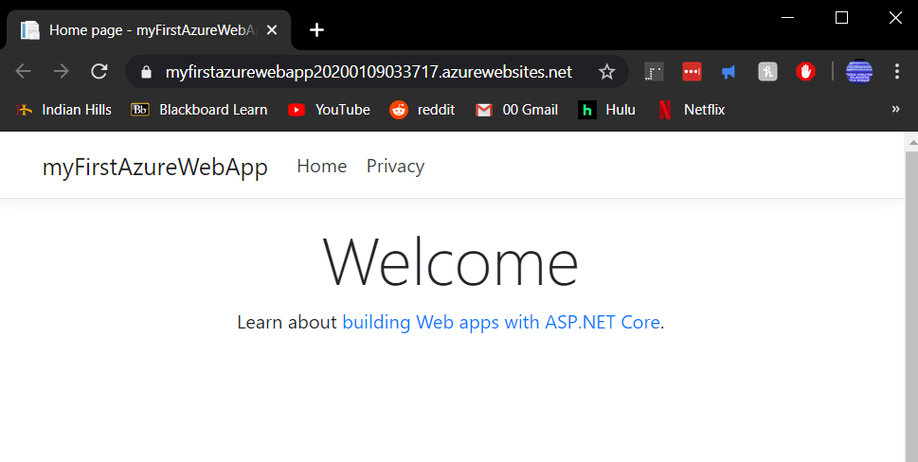

1. Sign in to your Azure Student account in your browser, and click on Resourse Groups from the dashboard. Click on your Azure web app that you just published. Do a screen print showing that your app is being managed in Azure.

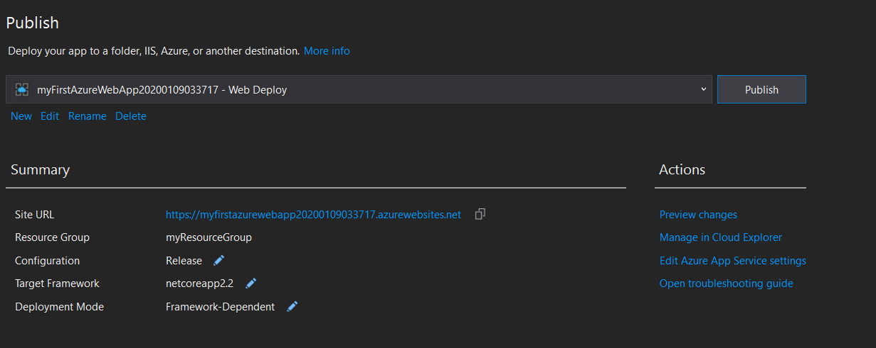

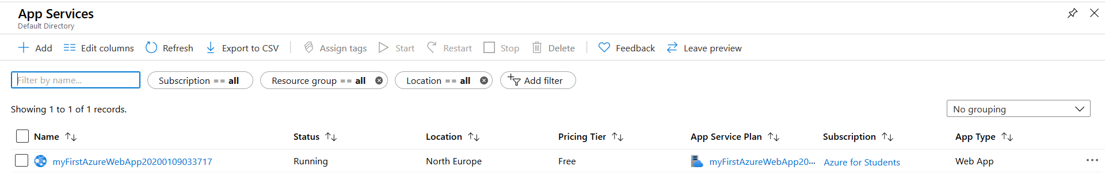

1. After making changes to the Index page and re-publishing, do a screen print of the new page running in your browser.

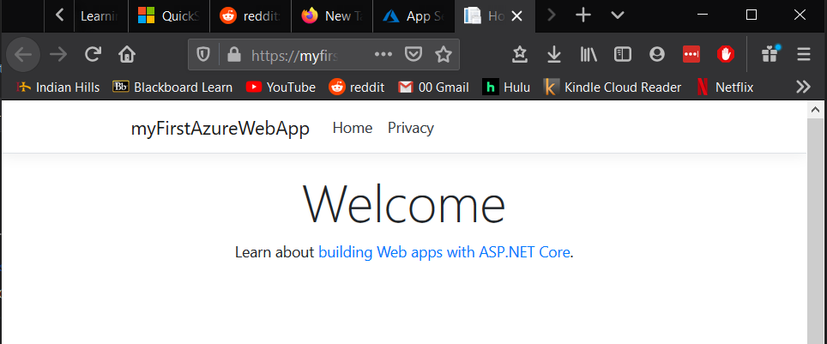

1. Repeat exercise 5 again, only this time click on Activity Log in the left pane, and do a screen print showing the time when your web app was updated.

